Bloomberg

Interest Rate Swap Trading

USD Interest Rate Swaps – SWPM <GO>

SWPM USD 10MM 5Y <GO>

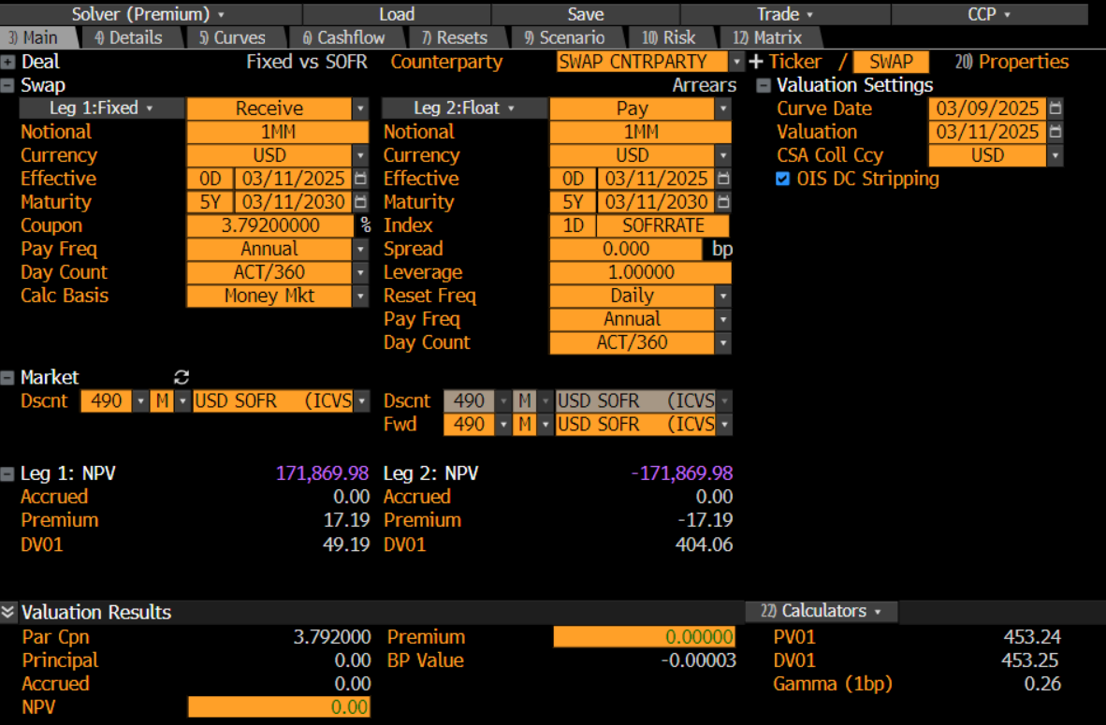

Fixed Cash Flows

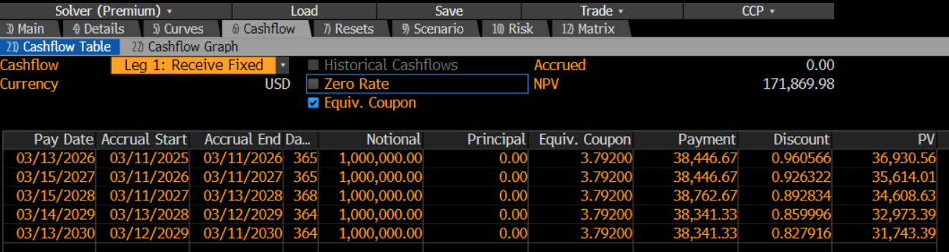

Float Cash Flows

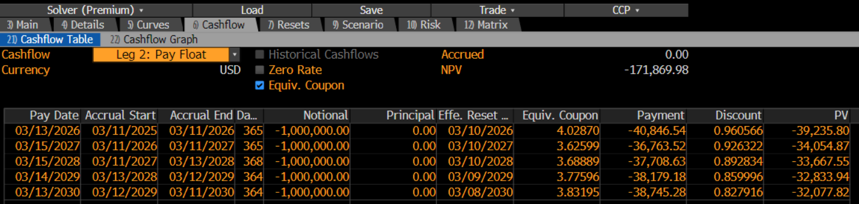

USD Swap Curves – ICVS <GO>

ICVS USD <GO>

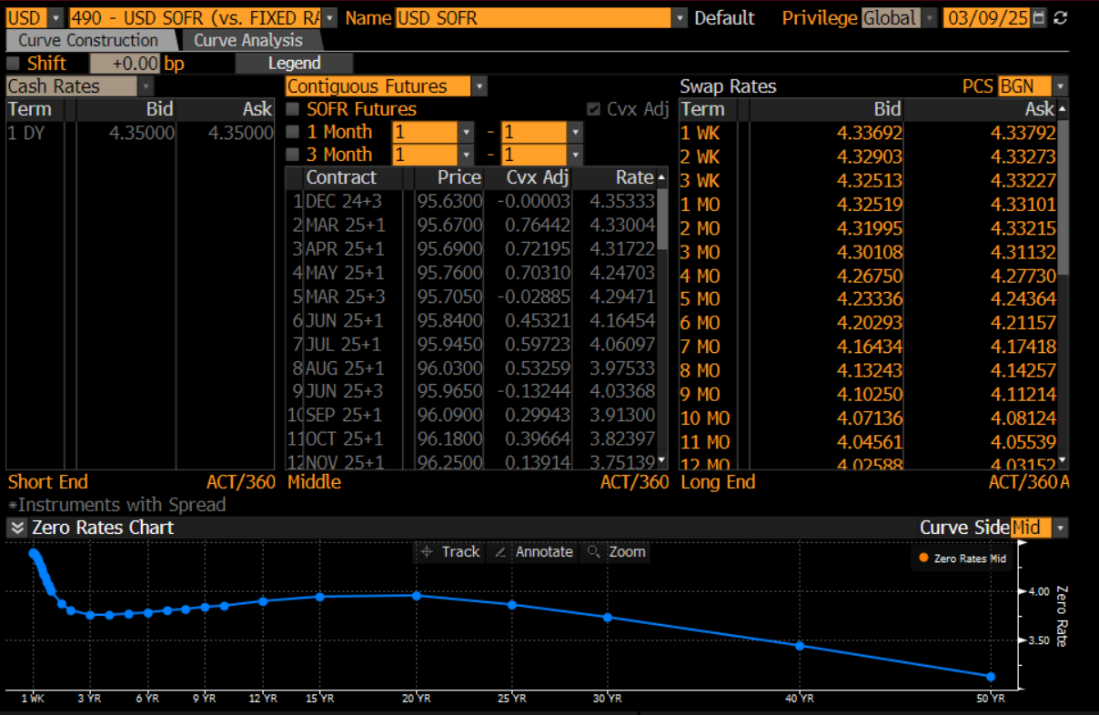

**STIR Futures**

1M or 3M Futures Contracts

Serial or Contiguous

* Serial 3M – Mar+3, Apr+3, May+3, Jun+3, etc. (Monthly Overlapping Futures Contracts)
* Contiguous 3M – Dec+3, Mar+3, Jun+3, etc. (Quarterly Non-Overlapping & Continuous)

Convexity Adjustments

Futures are marked-to-market with daily margin, this removes convexity (curvature). We must add this curvature back as swap curves are not marked-to-market and have no margin requirements.

Serial or Contiguous Futures

Serial Futures – Monthly Overlapping Contracts

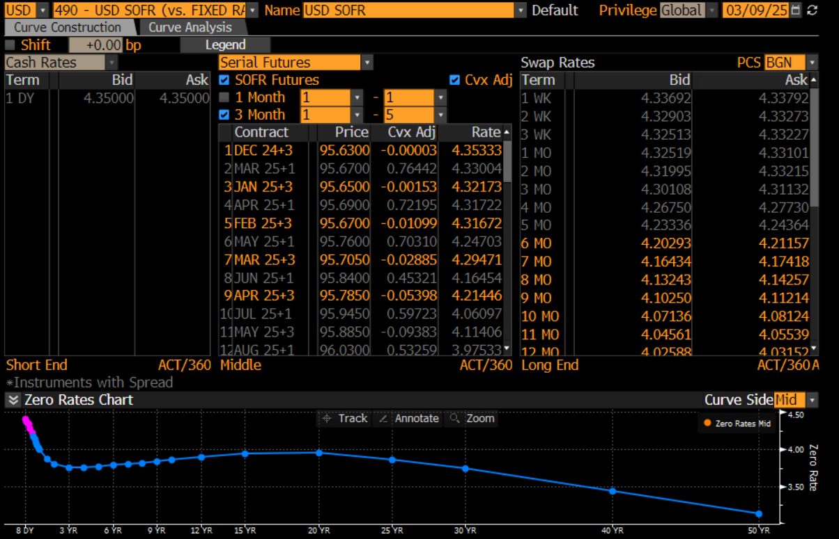

Contiguous Futures – Quarterly Continuous Contracts

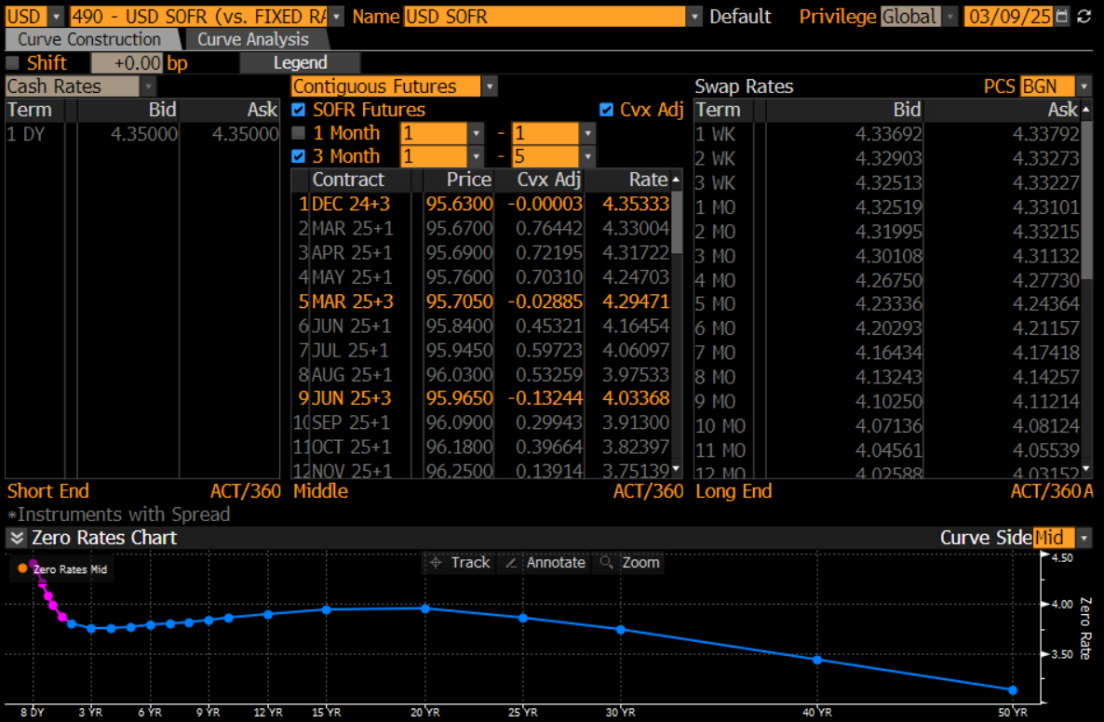

Interest Rate Benchmarks – IRSB <GO>

SOFR Swaps

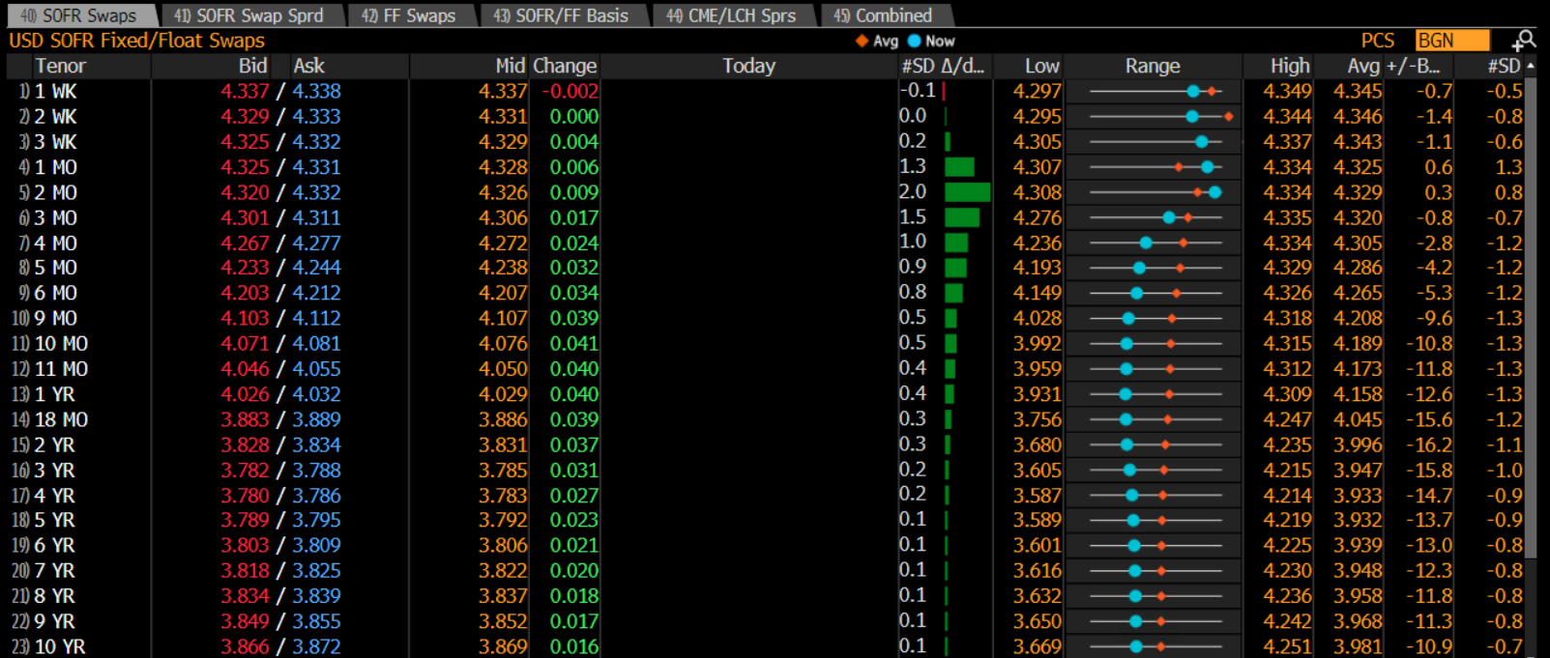

SOFR Swap Spreads - Spread over US Treasuries

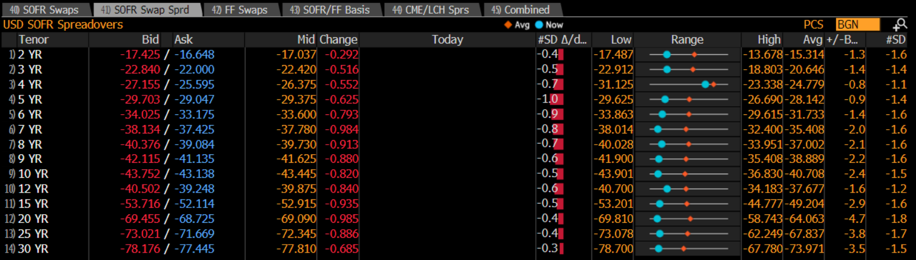

Combined

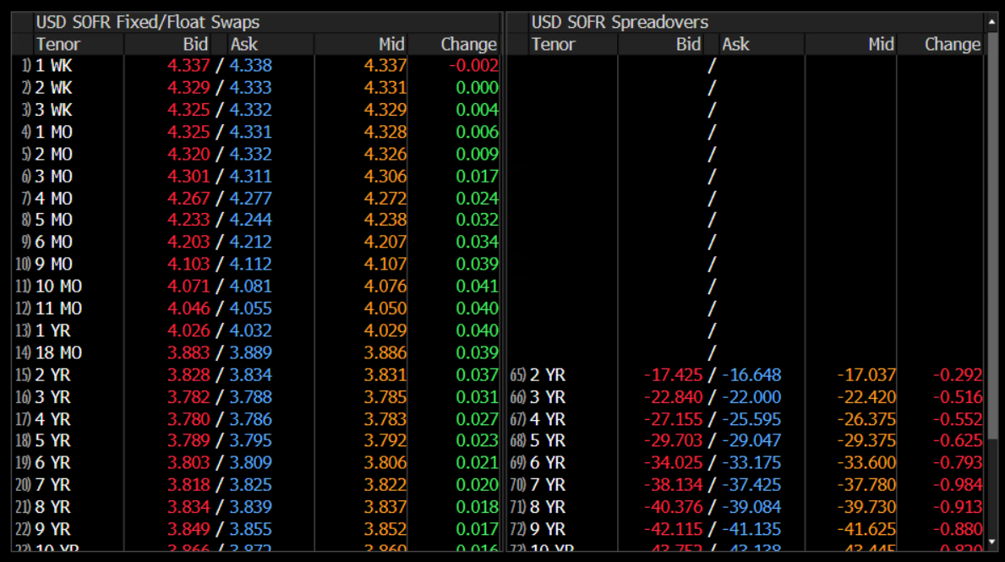

IRS Trading Portal – BBTI <GO>

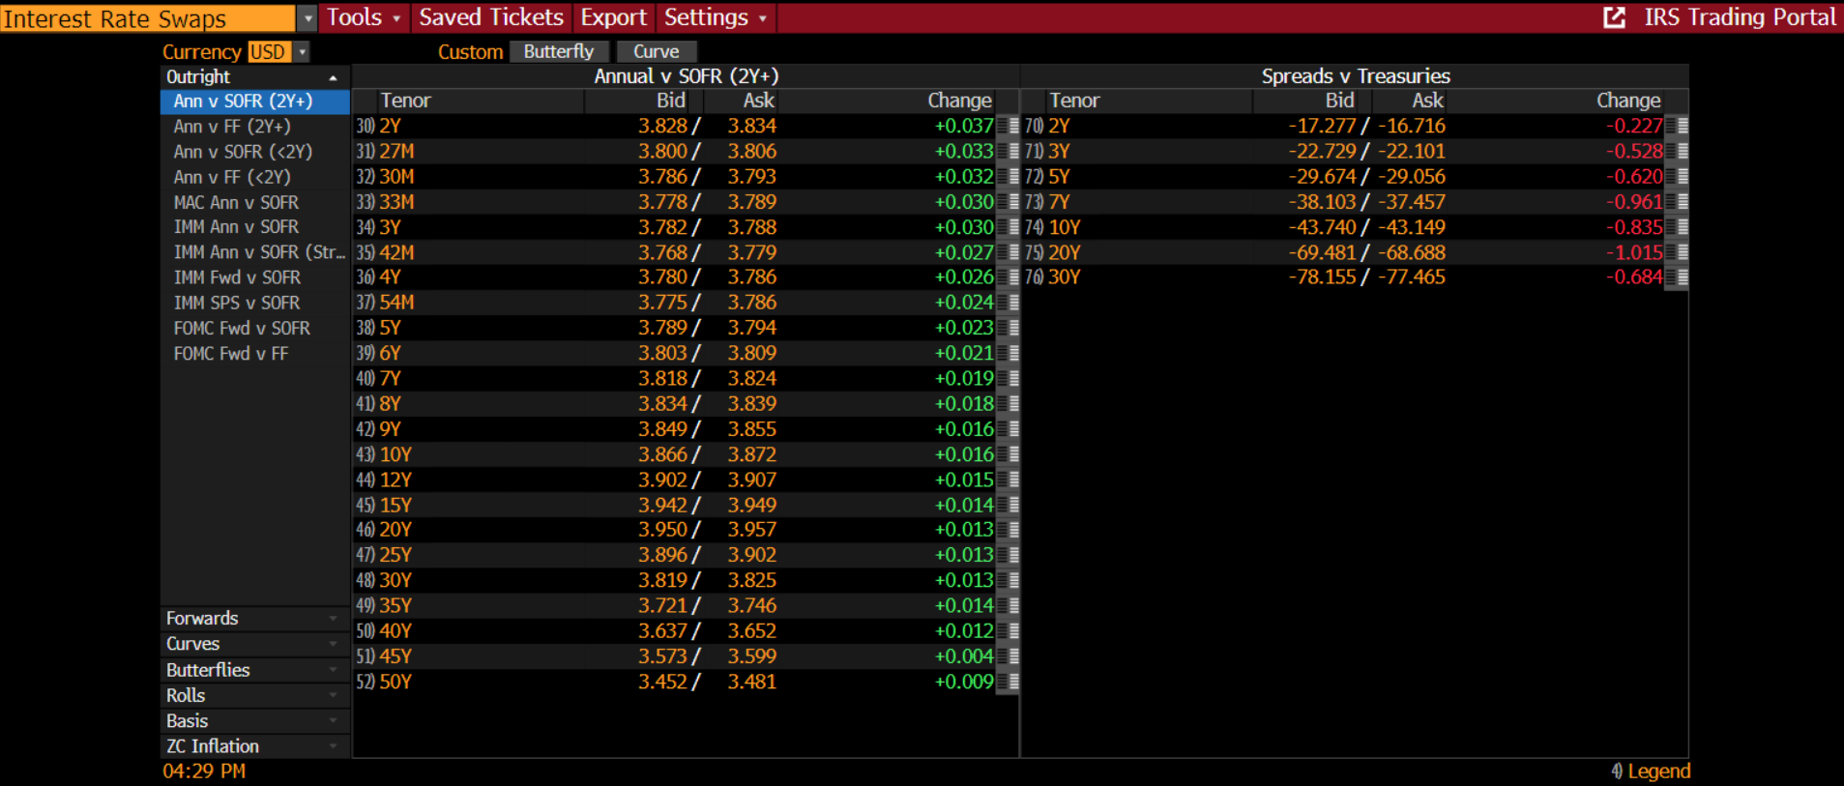

US Swap Market – USSW <GO>

